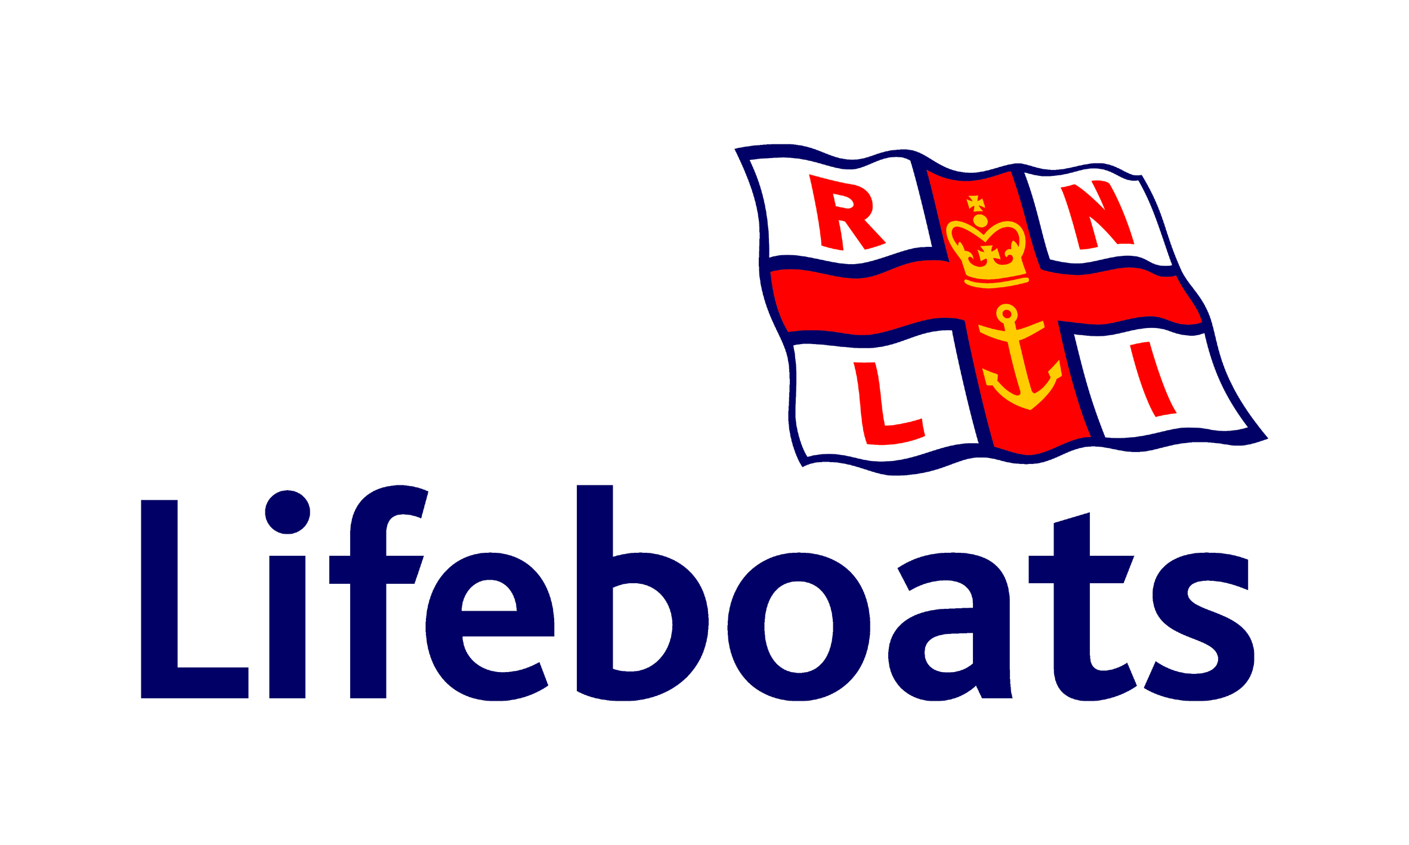

Falmouth Station
Lifeboat
Service
Custom House Quay
Falmouth

SUNDAY 7th August 2016
at 6.30pm

The Falmouth Lifeboats
will moor alongside the Quay and be
open to view by the public afterwards

